PFA GitHub repository link: <https://github.com/athulgopu/GreedyGameAssign> for code snippets.

1. Calculate the lifetime value (LTV) of the users acquired through different marketing channels?

**Steps to calculate the LTV:**

1. Calculate the average revenue per user for each marketing channel.
2. Calculate the average lifetime of a user for each marketing channel.
3. Multiply the average revenue with the average lifetime to get the lifetime value for each marketing channel.

**Step 1:**

avg_revenue as

( Select us.user_id,us.utm_source,uo.offer_id,uo.reward_id,r.total_revenue_in_paise

from user_signup_table us left join user_offer_table uo on us.user_id=uo.user_id

left join rewards_table r on uo.reward_id=r.reward_id and uo.offer_id=r. offer_id),

avg_revenue_channel as

(Select utm_source,avg(total_revenue_in_paise) from avg_revenue

group by 1),

**Step 2:**

avg_lifetime_channel as

(Select utm_source,avg(last_login_at – created_at) as avg_lifetime from user_signup_table

group by 1),

**Step 3:**

LTV as

(Select avg_revenue_channel .utm_source, (avg_revenue * avg_lifetime) as lifetime_value

from avg_revenue_channel left join avg_lifetime_channel on avg_revenue_channel.utm_source=avg_lifeti

1. Which app is better of the two: Sikka or Sikka Pro?

Attaching the code for approach and description.

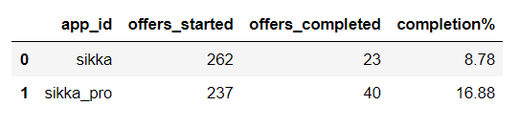

**In terms of completion rate its clear from the above data that sikka pro is better than sikka.**

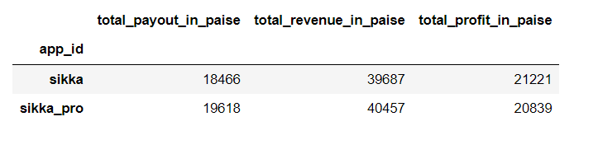

**In terms of revenue generation sikka pro had generated slightly more revenue than sikka.**

Even though the completion rate was higher for sikka pro and the total revenue generated was also slightly higher, the total profit generated was slightly lesser than that generated from sikka. One reason for this could be due to users completing a smaller number of high rewarding offers in sikka which returns more profit and users completing high number of low rewarding offers where the profit return is also lesser.

**So overall, since the total profit generated were almost equal, we can say that both the apps are performing equally good.**

1. Predict the number of referrals for these 15 days of November?

**Using a simple linear regression model, we were able to predict the Referrals for 15 days of November**. Attaching the code for approach and description.

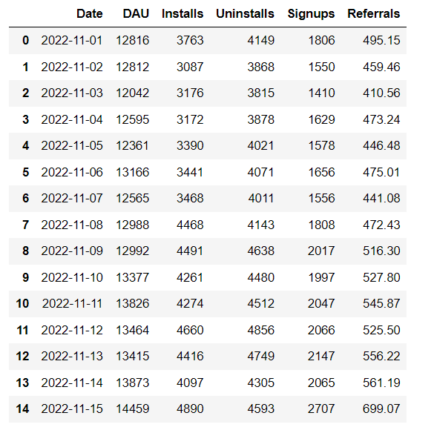

1. Find out if there is any anomaly present in the data for any of the apps present in the sample dataset?

Attaching the code for approach and description.

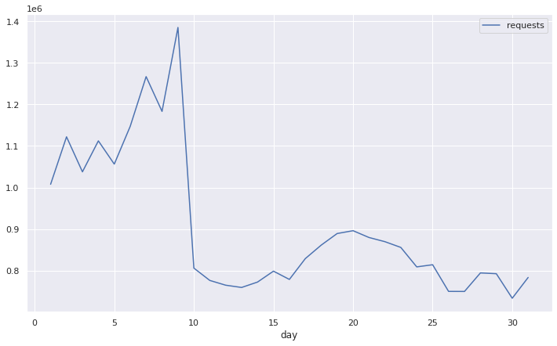

**Total requests day wise distribution**

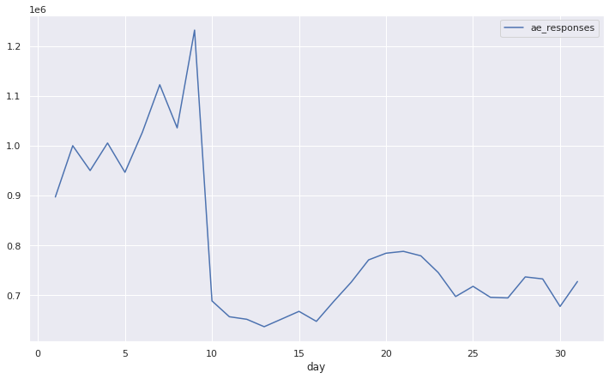

**Total responses day wise distribution**

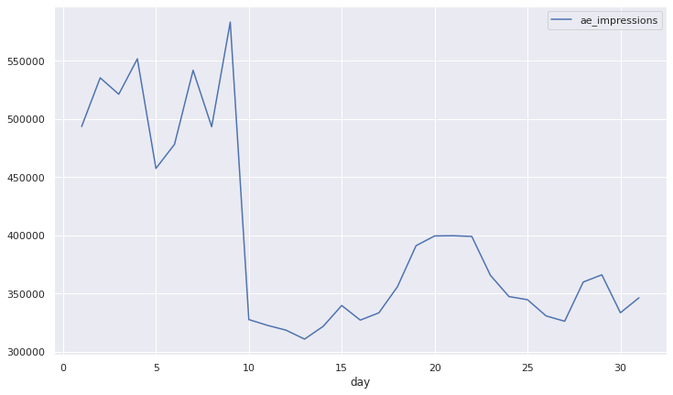

**Total impressions day wise distribution**

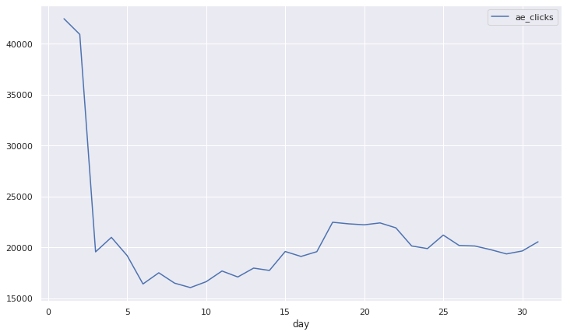

**Total clicks day wise distribution**

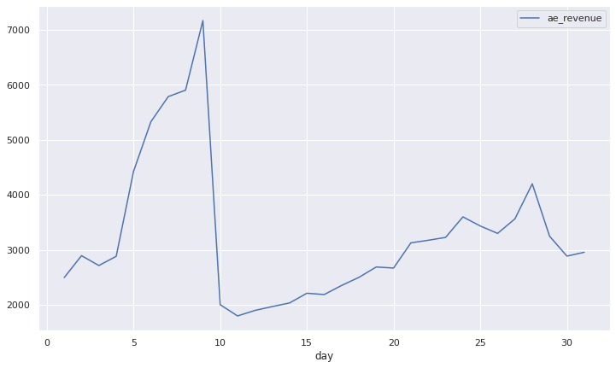

**Total revenue day wise distribution**

**As we can see from the above charts, if we look at a day wise distribution then total of all the metrics are following a same pattern with a sudden dip on 10th of the month except clicks which were very high during the first 2 days but then had a fall on 3rd day and became almost half and remained almost constant for the rest of the months which is kind of an anomaly.**

**We can observe that the app_id 66981243 is the one with very high number of clicks on initial 2 days but had a sudden drop as I seen from the below table and this could be some possible anomaly.**

**Also, the dip on the 10th day was caused by app_id 40931528, which had no requests after 10th. It had also generated a very good amount of revenue eventhough the click_rate is low. Infact it had generated the second highest revenue among all these apps,so the sudden drop of this app could be some anomaly.This could be caused maybe due to a technical issue or it may be a fraudulent activity and the app being a scam.**

